Hub

📡 What is a Hub?
# Source: Chatgpt (GPT‑5 Mini) at [12/18/2025]
A Hub is a basic network device used to connect multiple devices (like computers, printers, etc.) in a Local Area Network (LAN). It operates at Layer 1 (Physical Layer) of the OSI model and is often referred to as a "dumb" device because it has no intelligence — it simply broadcasts data to all connected devices, regardless of the destination.

🔧 Key Features of a Hub
# Source: Chatgpt (GPT‑5 Mini) at [12/18/2025]
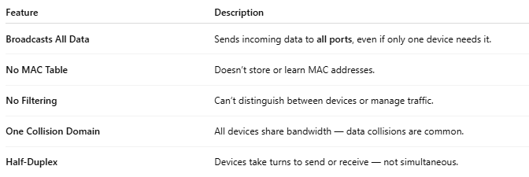

Feature | Description
Broadcasts All Data | Sends incoming data to all ports, even if only one device needs it.
No MAC Table | Doesn’t store or learn MAC addresses.
No Filtering | Can’t distinguish between devices or manage traffic.
One Collision Domain | All devices share bandwidth — data collisions are common.
Half-Duplex | Devices take turns to send or receive — not simultaneous.

📚 OSI Model Level
# Source: Chatgpt (GPT‑5 Mini) at [12/18/2025]


OSI Layer | Description
Layer 1 | Physical Layer – bit transmission, no data handling

🏠 Example Network with a Hub
# Source: Chatgpt (GPT‑5 Mini) at [12/18/2025]
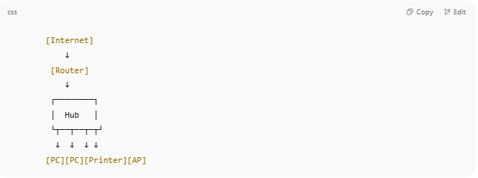

[Internet]
↓
[Router]
↓
┌────────┐
│ Hub │
└┬──┬──┬─┬┘
↓ ↓ ↓ ↓
[PC][PC][Printer][AP]

- When one PC sends data, everyone receives it, even if it’s not for them.
- Creates unnecessary network traffic.

🆚 Hub vs Switch
# Source: Chatgpt (GPT‑5 Mini) at [12/18/2025]
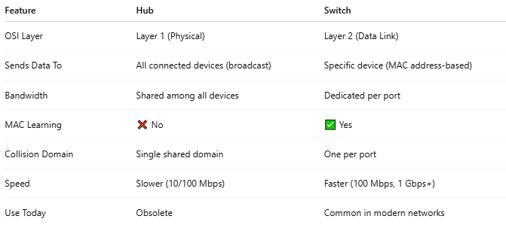

Feature | Hub | Switch
OSI Layer | Layer 1 (Physical) | Layer 2 (Data Link)
Sends Data To | All connected devices (broadcast) | Specific device (MAC address-based)
Bandwidth | Shared among all devices | Dedicated per port
MAC Learning | ❌ No | ✅ Yes
Collision Domain | Single shared domain | One per port
Speed | Slower (10/100 Mbps) | Faster (100 Mbps, 1 Gbps+)
Use Today | Obsolete | Common in modern networks

❌ Why Hubs Are Obsolete
# Source: Chatgpt (GPT‑5 Mini) at [12/18/2025]
- Inefficient (broadcast traffic to all)
- Not secure (any device can "listen" to all data)
- Poor performance in busy networks
- Replaced by smarter devices like switches and routers

✅ When Are Hubs Still Used?
# Source: Chatgpt (GPT‑5 Mini) at [12/18/2025]
- For network testing/labs (e.g., packet sniffing)
- Rarely in simple or legacy networks
- In education, for demonstrating broadcast behavior

